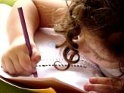  Writing  In Talk4Writing this half-term we will be writing our own wishing tale stories based on our model text, The Old Mill. We will focus on developing a character and using dialogue accurately. We will then be writing our own information text on a mythical beast from ‘The Old Mill’ remembering to organise information accurately using a range of punctuation. | Maths  In maths this half term we will be looking at ratio, algebra and decimals and how these relate to fractions.  We will continue to improve our times tables and mental arithmetic skills including recapping our key fraction skills from the autumn term. |  | Science  Evolution and Inheritance is our Science topic this half-term. We will be studying how species inherit characteristics as well as how they adapt and evolve. Our work will focus around Charles Darwin’s visit to the Galapagos and his discoveries, | Computing  In computing this half-term we will be looking at the ‘History of Media’ by using a range of devices to design and create different programs and thi8nk9ing how computer programs have changed the modern world we live in.
Humanities  Thinking about who Charles Darwin was, we will be studying his famous voyage of The Beagle and looking and The Galapagos Islands. From this we will study his theory of evolution and explore how his ideas impacted people at the time and their way of living. | 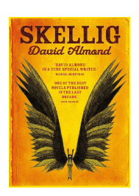  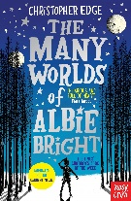  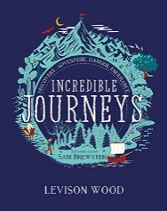  Our class books  Skellig by David Almond  Darwin’s Voyage of Discovery  Incredible Journeys  Poetry – The work of William Blake |  |  | RSHE  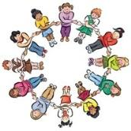  In RSHE this half term we will be thinking about citizenship and our human rights including how responsibility and democracy are used with Britain
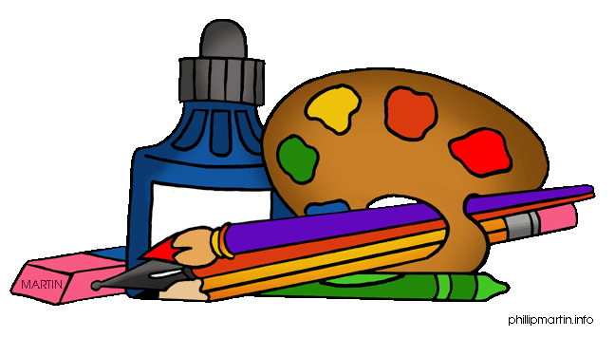  Art and DT  We are going to be focusing on Activism artists Luba Lukova, Faith Ringgold, and Shepard Fairley. We will reflect on their work, explore topics or themes we care about to create a piece of art work inspired by these artists. This will all be done through our sketch books by recording our observations. | PE  In PE this half-term we will be taking part in High 5 netball, using our core invasion game skills of defending and attacking in competitive environments. This will help us understand positioning and tactics.  We will also be continuing swimming looking at being able to swim competently over 25metres using a range of strokes. | Music  In music this half-term we will be studying ‘Film Music’. Children will know what a film soundtrack includes and understand major and minor key signatures use note pitches that chow different emotions within a film. |  | RE  In RE this half-term we will be looking at ‘What do religions say when life gets hard?’ We will reflect on our own ideas about why religion can help believers when times get hard including beliefs on life after death and the afterlife.

